1. **Explain Vlookup?**

Answer: VLOOKUP stands for Vertical Lookup. When we have two tables, one having limited columns and some of the data has to be found from the other table which has a unique identifier present, and the identifier is present in row order then we use VLOOKUP. VLOOKUP has 4 arguments,

1. What data are we looking for,
2. Map with the first column of the Unique identifier to the total columns to the right till where we need data,
3. Count of columns (must be a positive number & not 0),
4. Do you want it to be matched exactly same or approximate is sufficient (0 = Exact, 1 = Approx.[FALSE,TRUE].
5. **What happens if the fact table has multiple entries of unique identity in a fact table to the VLOOKUP?**

Answer: Lookup matches the searched data in the given row from top to the bottom & if the Unique value that you are searching is present more than once in the fact table, the output will be of the first row.

Assuming I have same phone number repeated for two employees and when I try do get the use name by using this phone number the returned result will be of the first row from the top, the result will not explicitly mention there were two rows having same number.

1. **Can I do VLOOKUP matching column which is to the right and the data to pick up is to the left?**

Answer: VLOOKUP is suited for data being arranged from the first column as the unique identifier(common column) and the corresponding(Result column in source table) data to the right side of the Unique column. If the Unique column is to the right and we want the required data is towards the left from the unique identifier, then VLOOKUP will give error.

To avoid this, VLOOKUP can be used with CHOOSE().Combination of such VLOOKUP is not only tedious task but becomes more tedious if the columns are more or increasing.

To avoid this there are several other alternatives, like using INDEX with MATCH functions.

1. **Explain what is Index function?**

Answer: INDEX is one among the most versatile functions. INDEX gets output from an array (table), it has 3 mandatory parameters array, row_num & column. Assuming the table has 100 rows with 4 columns, the INDEX would have the array of 4 columns with 100 rows, the row number I want the data from followed with the column number, the output will result in single value from the indexed location.

1. **What is the used case of Index with Match?**

Answer: INDEX is one among the most versatile functions. INDEX gets oupt from an array (table), it has 3 mandatory parameters array, row_num and the column number. MATCH finds a number or a text value from a given condition, MATCH has 3 mandatory arguments, what to match, array to match & match type (-1 less match, 0 exact match & 1 greater match).

A used case could be extracting data from table 1 which has all the corresponding details & table 2 is expected fetch only a selected number of row, in the table 2 we have similar row identity and column names are same, by using match we can get the row & column number, we use this with INDEX to retrieve the desired data.

1. Which function is best used to look up and retrieve data from a specific row in a table?
   1. HLOOKUP
   2. MATCH
   3. **VLOOKUP**
   4. ADDRESS
2. Which function returns a reference to a cell (or cell range) that is a specified distance from a base cell?
   1. **OFFSET**
   2. VLOOKUP
   3. INDEX
   4. MATCH
3. . In the formula =VLOOKUP(A1,D1:H30,3,FALSE), the lookup value (A1) is being looked for in _.
   1. **column D**
   2. columns D through H
   3. column H
   4. column F
4. Which VLOOKUP function, when entered into cell L2 and then dragged to cell L5, returns the average number of calls for the representative IDs listed in column J?  
   [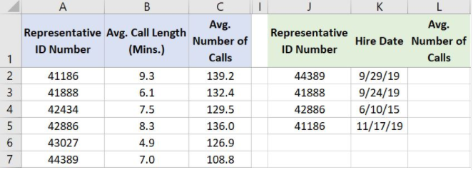](https://github.com/Ebazhanov/linkedin-skill-assessments-quizzes/blob/main/microsoft-excel/images/Q63.png?raw=png)
   1. =VLOOKUP(A2,J2:L5,1,FALSE)
   2. =VLOOKUP(J2,A$2:C$7,1,FALSE)
   3. **=VLOOKUP(J2,A$2:C$7,3,FALSE)**
   4. =VLOOKUP(J2,A2:C7,3,FALSE)
5. In the worksheet shown below, cell C6 contains the formula=VLOOKUP(A6,$F$2:$G$10,2,FALSE). What is the most likely reason that #N/A is returned in cell C6 instead of mallory's ID (2H54)  
   [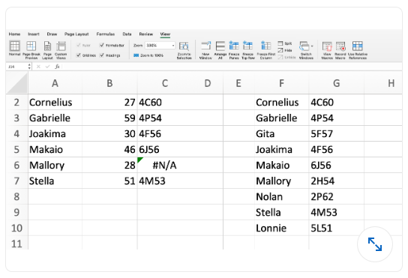](https://user-images.githubusercontent.com/23659530/179216823-1ac09896-4807-4bd6-a352-637df79e7b36.png?raw=png)
   1. The absolute/relative cell references in the formula are wrong
   2. Cell A6 is not actualy text its a formula that need to be copied and pasted as a value
   3. Column C in the lookup range is not sorted properly
   4. **A trailing space probably exist in cell A6 or F7**
6. To ensure the VLOOKUP function returns the value of an exact match, what do you need to enter into the Range_lookup field?  
   [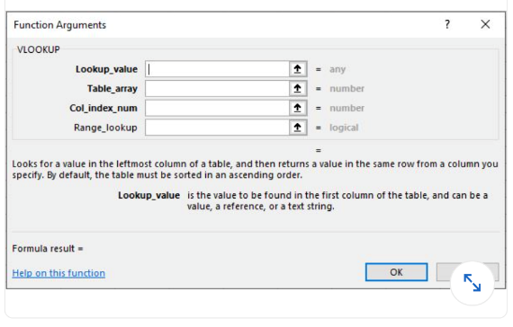](https://github.com/Ebazhanov/linkedin-skill-assessments-quizzes/blob/main/microsoft-excel/images/Q79.png?raw=true)
   1. **0**
   2. 1
   3. **FALSE**
   4. TRUE
7. What does the VLOOKUP function do?
   1. Looks up text that contain V
   2. Checks whether text is the same in one cell as in the next
   3. **Finds related records**
   4. All of above
8. A function inside another function is called _______
   1. **Nested function**
   2. Round function
   3. Sum function
   4. Text function
9. Which of the formulas below contain the correct syntax (formula arguments) for the VLOOKUP function?
   1. **=VLOOKUP(lookup_value, table_array, col_index_num, range_lookup)**
   2. =VLOOKUP(table_array, lookup_value, col_index_num, range_lookup)
   3. =VLOOKUP(lookup_value, table_array, col_index_num, value)
   4. =VLOOKUP(lookup_value, lookup _array, col_index_num, range_lookup)
10. In a VLOOKUP formula, what does the argument column_index_number mean?
    1. a) This is the secret INDEX number that each column in an Excel worksheet has.
    2. **b) This is the number of the column within the selected table_array where the lookup result is located.**
    3. c) This is a numerical representation of the letters at the top of a worksheet. For example, A = 1, B = 2, etc.
    4. d) This is numbers you assign to columns in your worksheet.
11. Which of the following is NOT possible with VLOOKUP?
    1. a) You can lookup values located in a different worksheet.
    2. b) You can lookup values located in a column to the right of the column that contains the lookup value.
    3. **c) You can lookup values located in a column to the left of the column that contains the lookup value.**
    4. d) You can lookup values such as text, numbers or characters.
12. What type of result does the MATCH function, when used on its own, return?
    1. a) It returns the lookup value located in a specific location.
    2. b) It returns a value that is the same as the lookup value.
    3. c) It returns the cell reference of the lookup value.
    4. **d) It returns the relative position of a lookup value, either as a row or column number, within the selected array.**
13. . To find the employee who received the most salary, you will use the following formula –
    1. **(a) =INDEX(B5:B24,MATCH(MAX(F5:F24),F5:F24,0))**
    2. (b) =INDEX(B5:B24,MATCH(MAX(F5:F24),F5:F24,1))
    3. (c) =INDEX(B5:B24,MAX(F5:F24),0)
    4. (d) =INDEX(B5:B24,MATCH(MAX(F5:F24),F5:F24,-1))
14. Using which function from the list you can return a random name –
    1. **(a) =INDEX(B5:B24,MATCH(RANDBETWEEN(1,20),B5:B24,0))**
    2. (b) =INDEX(B5:B24,RANDBETWEEN(1,20))
    3. (c) =INDEX(B6:B25,RAND())
    4. (d) =INDEX(B6:B25,RAND(20))
15. To return value from the left side of the matched value, we can use –
    1. **(a) VLOOKUP Function**
    2. (b) Combination of VLOOKUP and IF Functions
    3. (c) HLOOKUP Function
    4. (d) ZLOOKUP Function